***Florida International University***

*School of Computing and Information Sciences*

CIS 4911 - Senior Capstone Project

Software Engineering Focus

Instructor Manual

Strategic Marketing Simulator 1.0

Team # 15

**Team Members**

Jeffrey Carman

Javier Andrial

**Product Owner**: Joseph Cilli

**Instructor**: Masoud Sadjari

Table of Contents

***Florida International University*** 1

Add administrative user 3

Add a bot user group 3

Views users for a game 4

My account management page 6

Change recovery options 6

Change password 8

News management 8

Comment Repository and reports 10

Comments 10

Reports 11

Report output 12

## Add administrative user

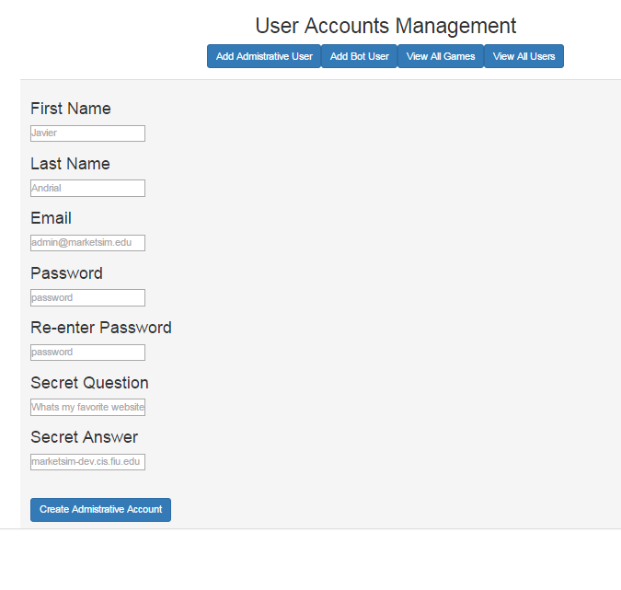

<http://marketsim-dev.cis.fiu.edu/views/ManagePage.php?addAdminUser=Add+Admistrative+User>

Enter information for the administrator in the corresponding textboxes and click “create administrative account” button.

## Add a bot user group

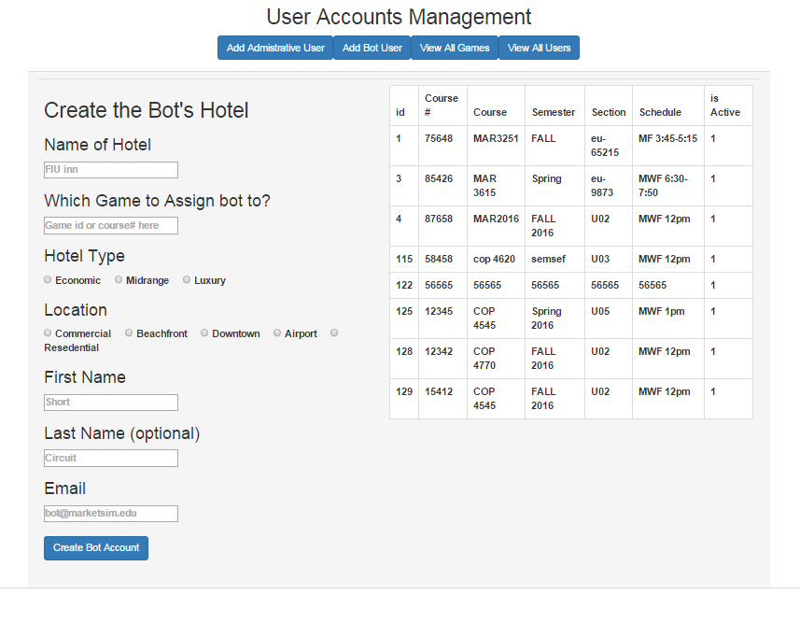

<http://marketsim-dev.cis.fiu.edu/views/ManagePage.php?addBotUser=Add+Bot+User>

Enter name of hotel, game to assign the hotel too, location, hotel type and name and click the “create bot account” button.

## Views users for a game

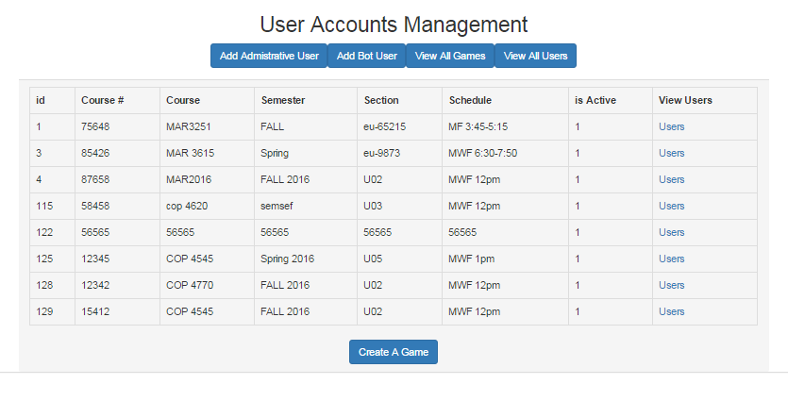

<http://marketsim-dev.cis.fiu.edu/views/ManagePage.php?viewAllGames=View+All+Games>

Click on the users link in the row corresponding to the game you want to view the users for.

Activate or deactivate users

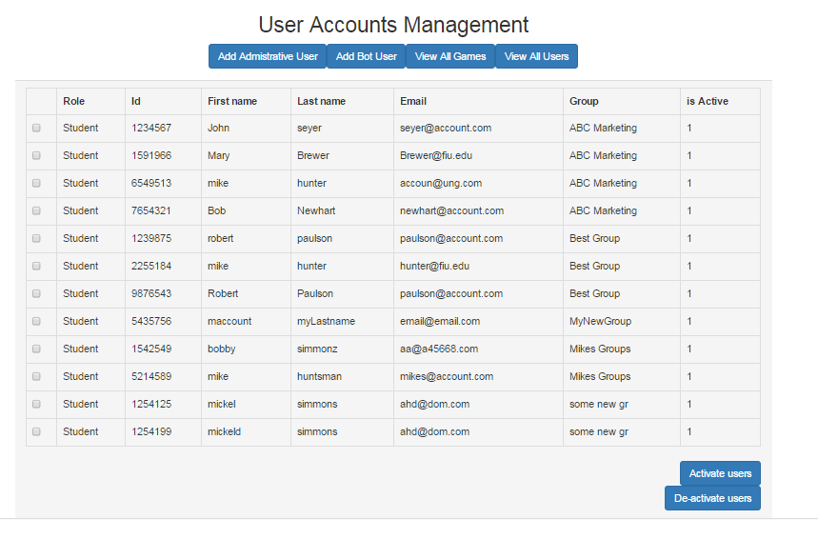

http://marketsim-dev.cis.fiu.edu/views/ManagePage.php?viewUsersForGame=true&game=1

After clicking on “users” link from the previous section, you can deactivate or activate users using the corresponding buttons on the view all users page

## My account management page

### Change recovery options

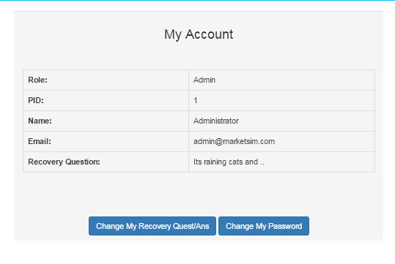

<http://marketsim-dev.cis.fiu.edu/views/accountManage.php>

Click on change my recovery quest/anw button to change your recovery question and answer/

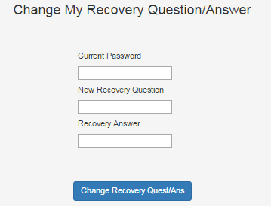

Next, enter a new question and answer in the corresponding text boxes and click change my recovery options button

### Change password

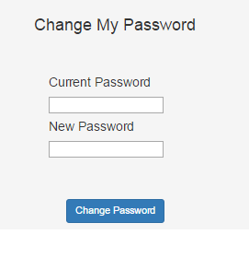

Enter a new username and password and click the “change password button”

## News management

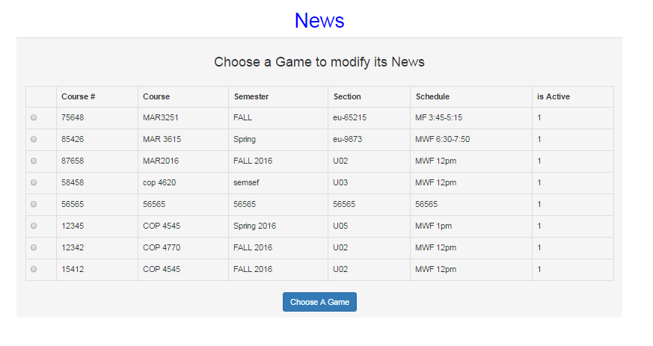

http://marketsim-dev.cis.fiu.edu/views/News.php

Select the game for which you would like to write a news article. Then click the “choose game” button.

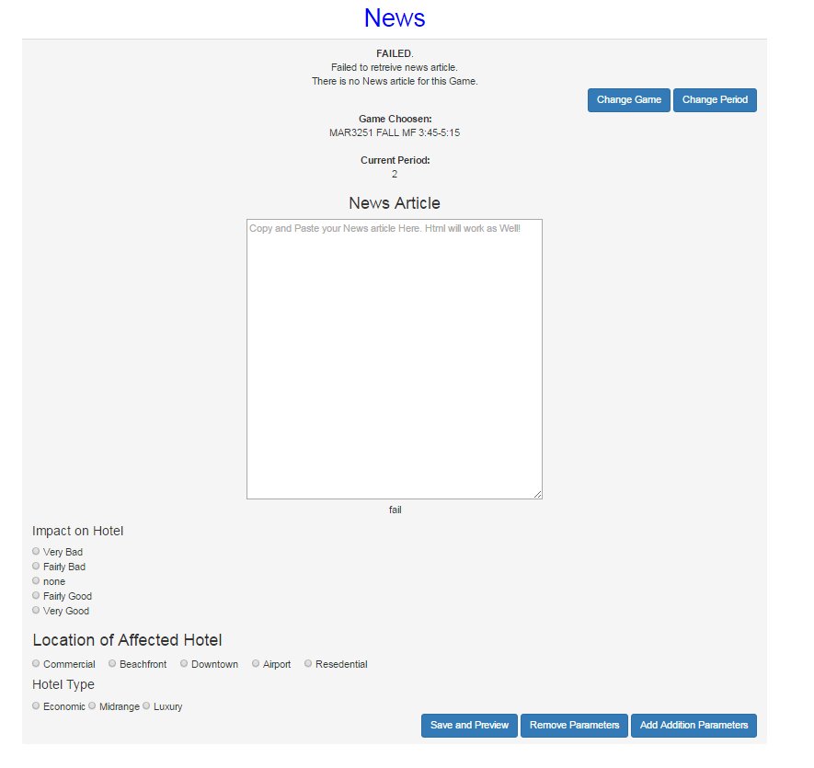

Next enter the text for a news article, select the impact radio button, the location radio button, and click save and preview. You can also change the game and period from this page by clicking the corresponding buttons.

## Comment Repository and reports

### Comments

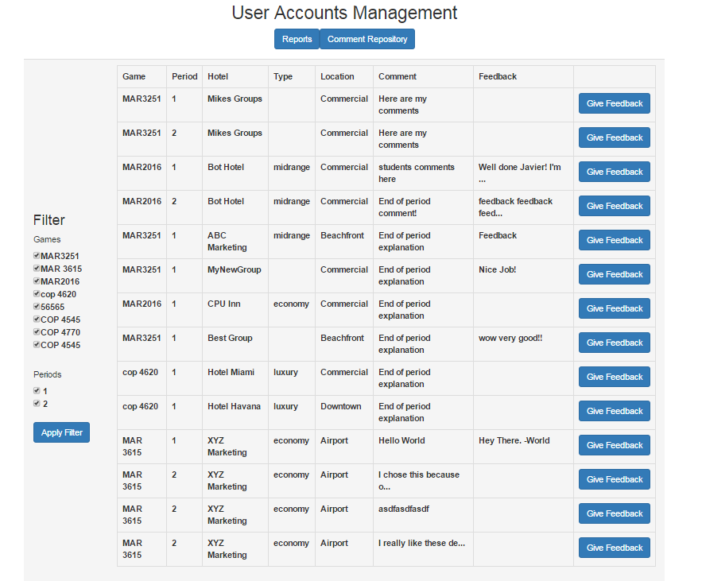

click on the comments repository button and select a group to give comments to for that period.

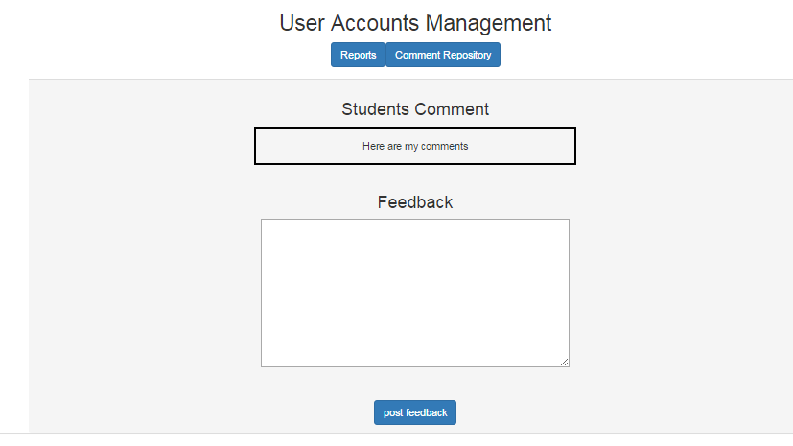Next enter your comments for that group and click the “post feedback” button.

### Reports

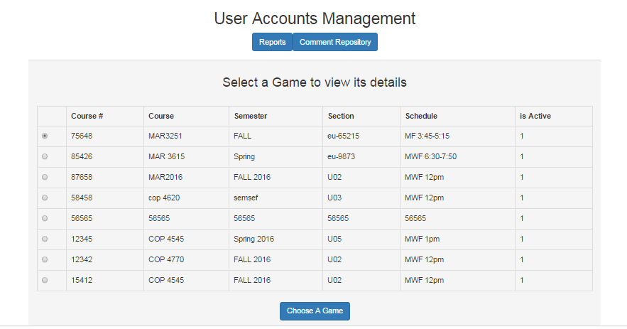

http://marketsim-dev.cis.fiu.edu/views/reportingPage.php?button_reports=Reports

Select the game for which you would like to run a report and click “choose a game” button. On the next page, select the period and click choose a period button.

## Report output

